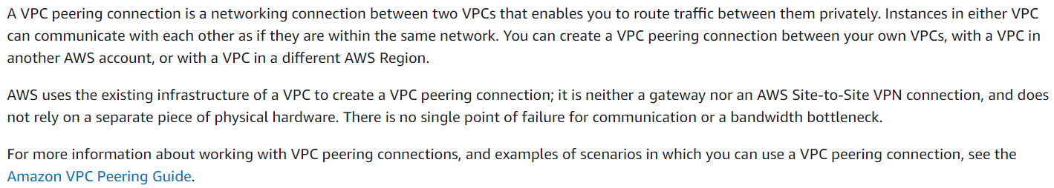

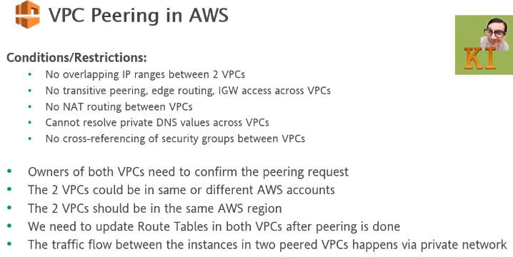

* If two VPCs wants to connect each other either from same or different account, we need VPC peering
* No cross-referring security groups between VPCs
* Create two VPCs with different CIDR range
* Earlier, peering was able to be done between the VPCs which are same region
* Now we can do peering between the VPCs which are in different regions also. It can be done between two account also
* The benefits of VPC is we can connect to the instance in other VPC with its private IP
* CIDR block should not be overlapping between the VPCs which we want to be peering

**Peering with different VPCs in same account:**

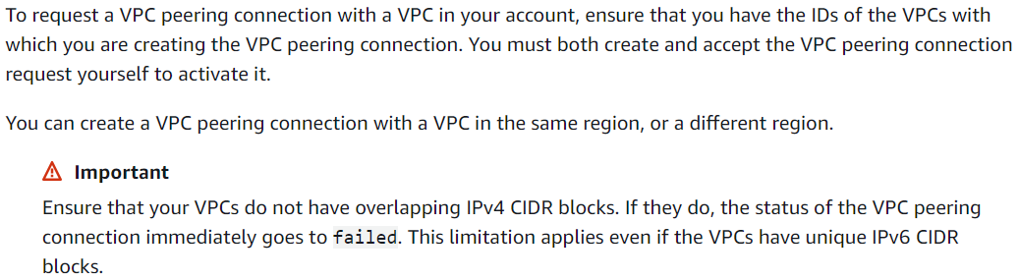

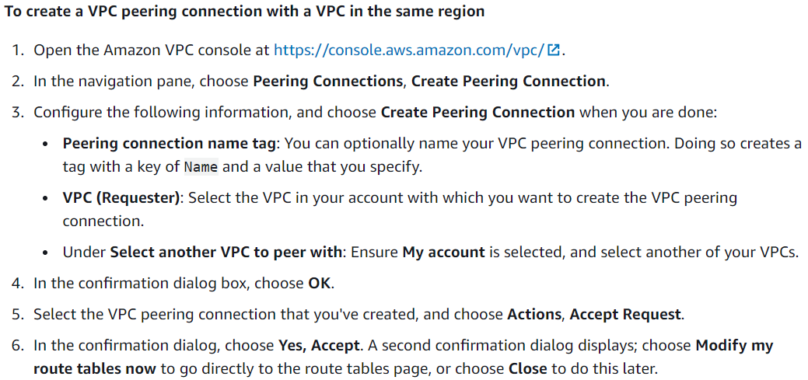

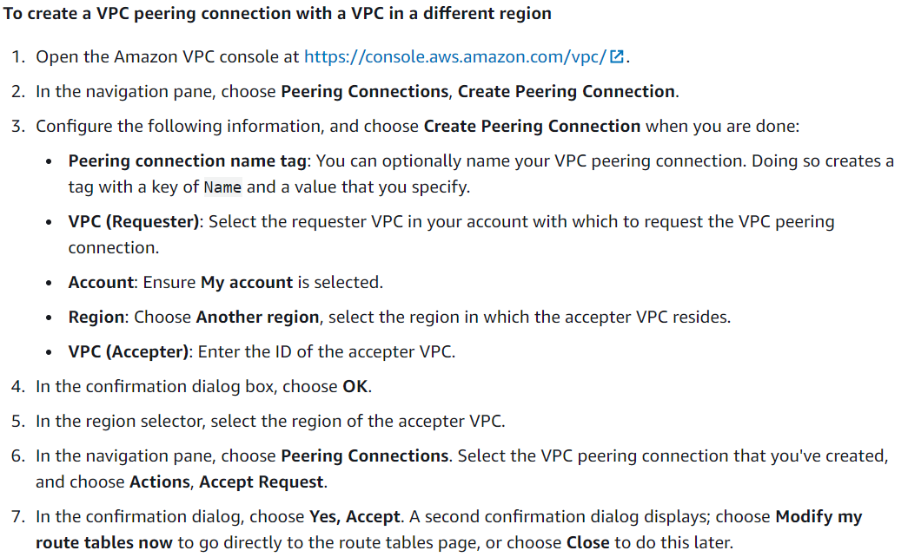

**Peering with VPC in another account:**

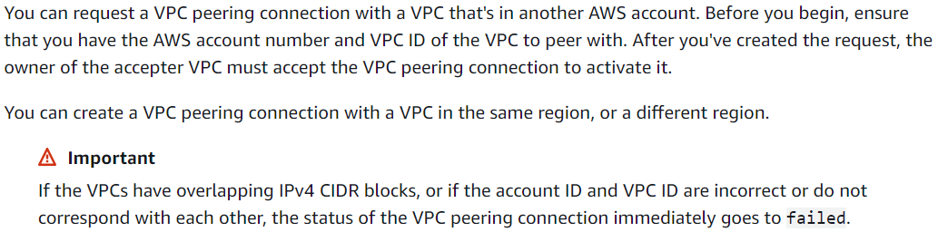

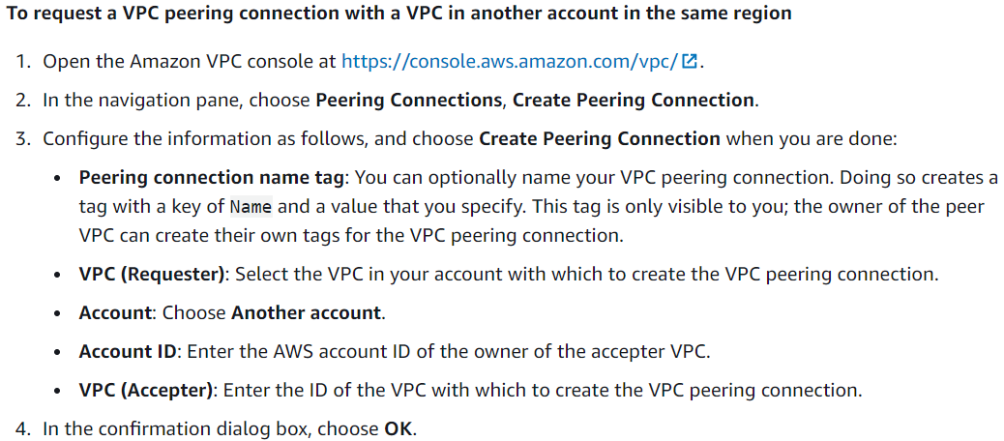

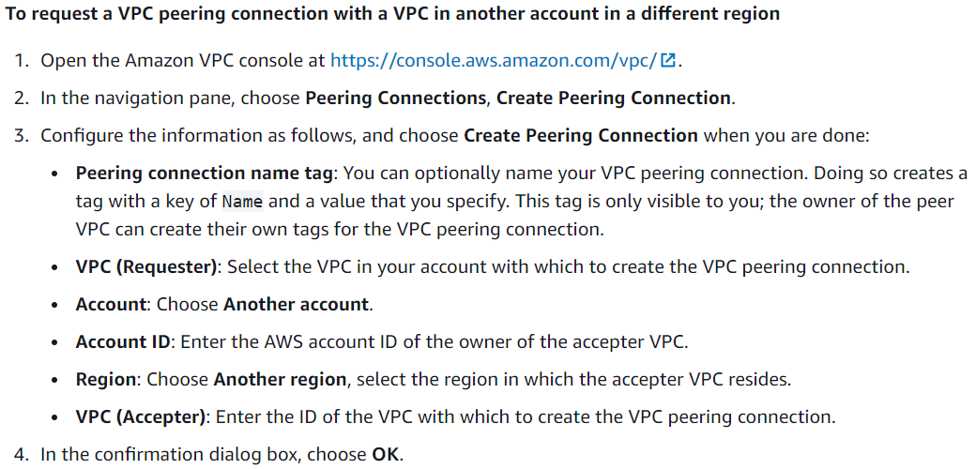

**Accept peering connection:**

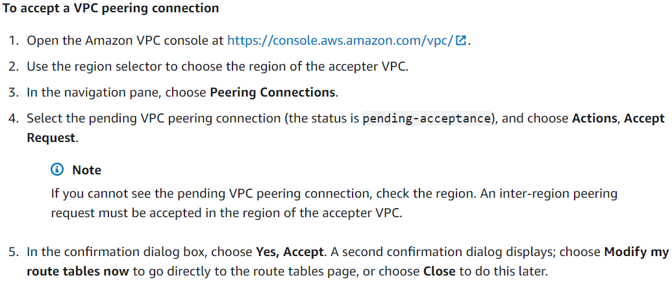

**View peering connections:**

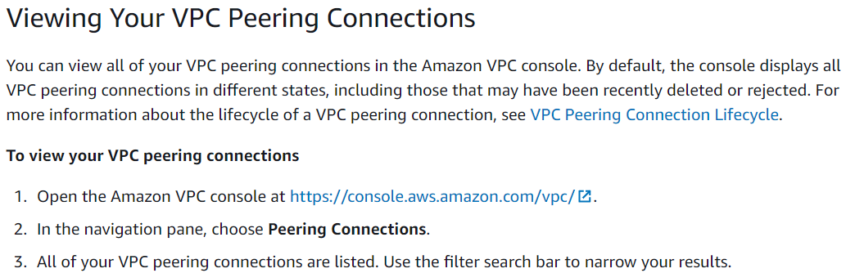

**Practical:**

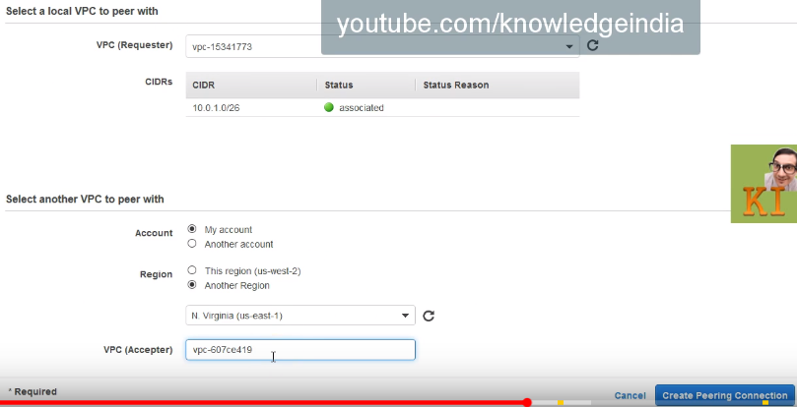

* Now create the VPC as above. If it is in another region, we need to select as above
* If we go to other region, we can see the peering connection is pending for acceptance. Go to actions and accept it

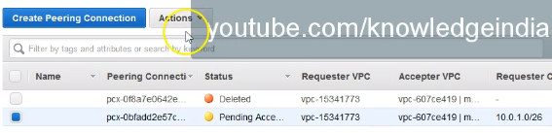

* Once we accept it, the status will be changed to active

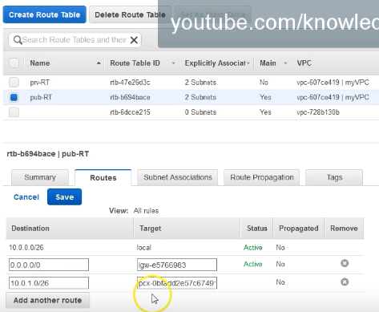

* Now enable the routing to the other VPC with its CIDR as above in public subnet

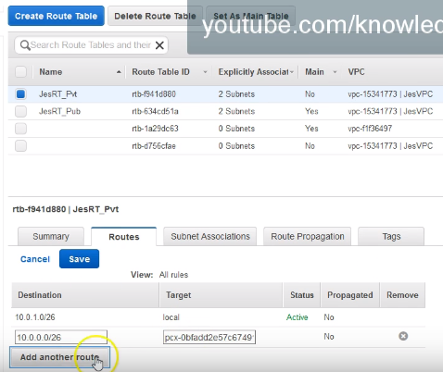

* Same way we need to enable from another VPC as well under private subnet

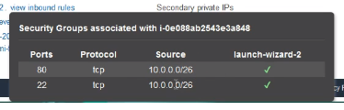

* We also need to configure the security group to allow the traffic from VPC1 as above
* Now, we can able to access the private instance of VPC2 from public instance VPC1